Name: ______________________________________________________________ Date: ____________
Video: How to Grow Carnivorous Plants Outdoors

Cold hardy perennials like Venus flytraps, Sarracenia, and cold hardy sundews grow in areas that experience hot summers and cold to icy winters.

Draw and color in the background of these images to show the four seasons a Venus flytrap would encounter in the wild:
Winter Spring
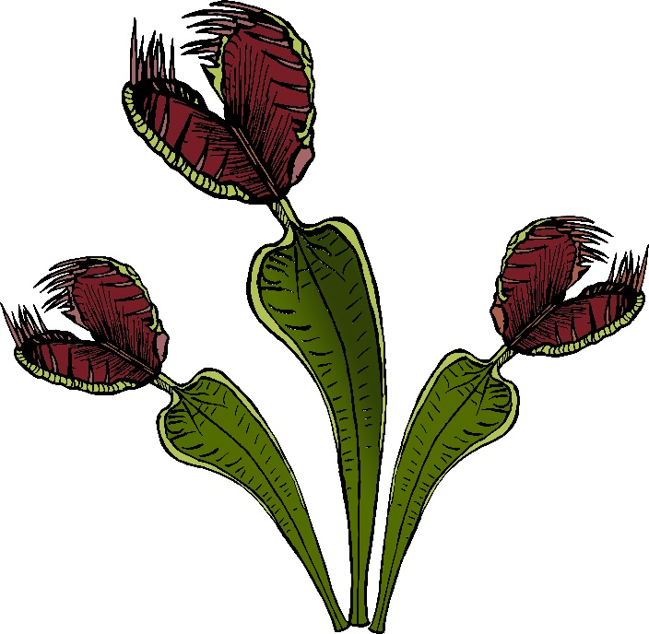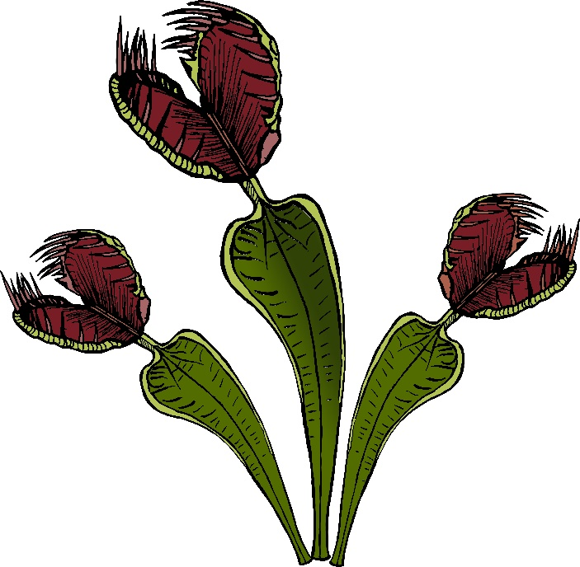
Summer Fall

