The Weird, Wild, Wacky and Wonderful World of Carnivorous Plants Workbook

This workbook belongs to .

Sundew facts

• How many kinds (species) of sundews are there?
• Are sundews found in our area?
• Where else do sundews occur?

• On which continent are the most different kinds of sundews found?
• Sundews occur on soils that are nutrient
• Sundews occur on moist
• How do sundews catch insects?

• To grow indoors, sundews need

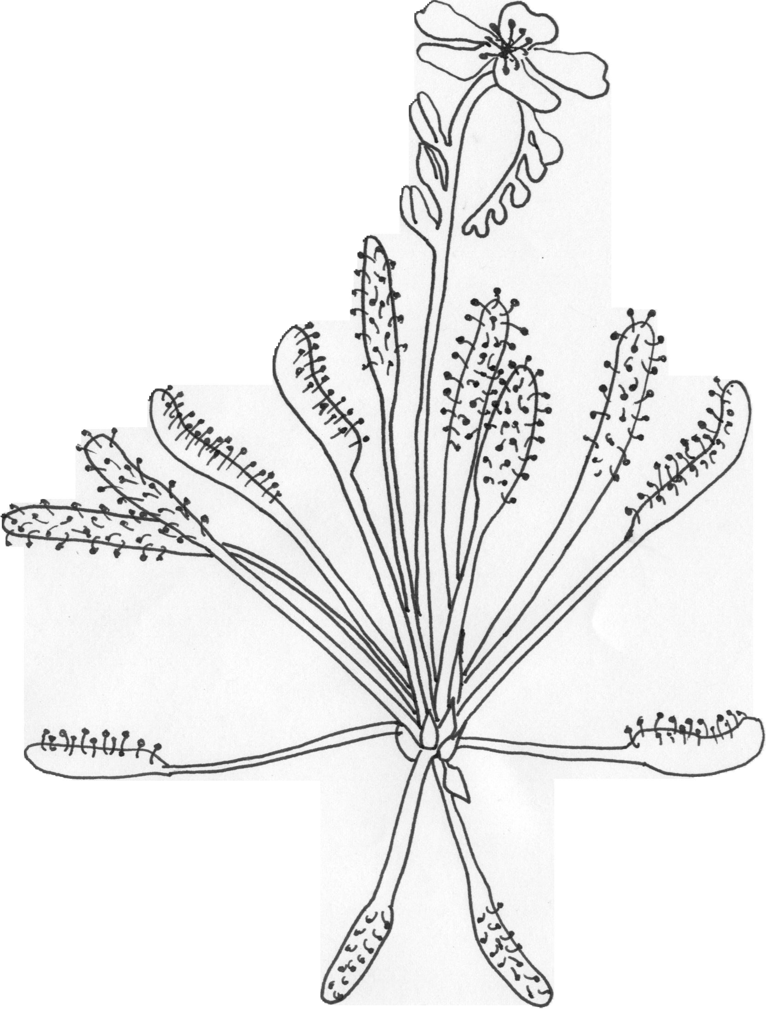

The cape sundew originates from Cape Province, South Africa. It has pink flowers.

My story about sundews

My drawing of sundews

Butterwort facts

• How many kinds (species) of butterworts are there?
• Are butterworts found in our area?
• On which hemisphere (northern or southern) are the most different kinds of butterworts found?

• The small glands on the leaves of the butterwort produce
to digest prey.
• Butterworts catch insects in order to obtain
they can not get from soil.
• To grow indoors, butterworts need

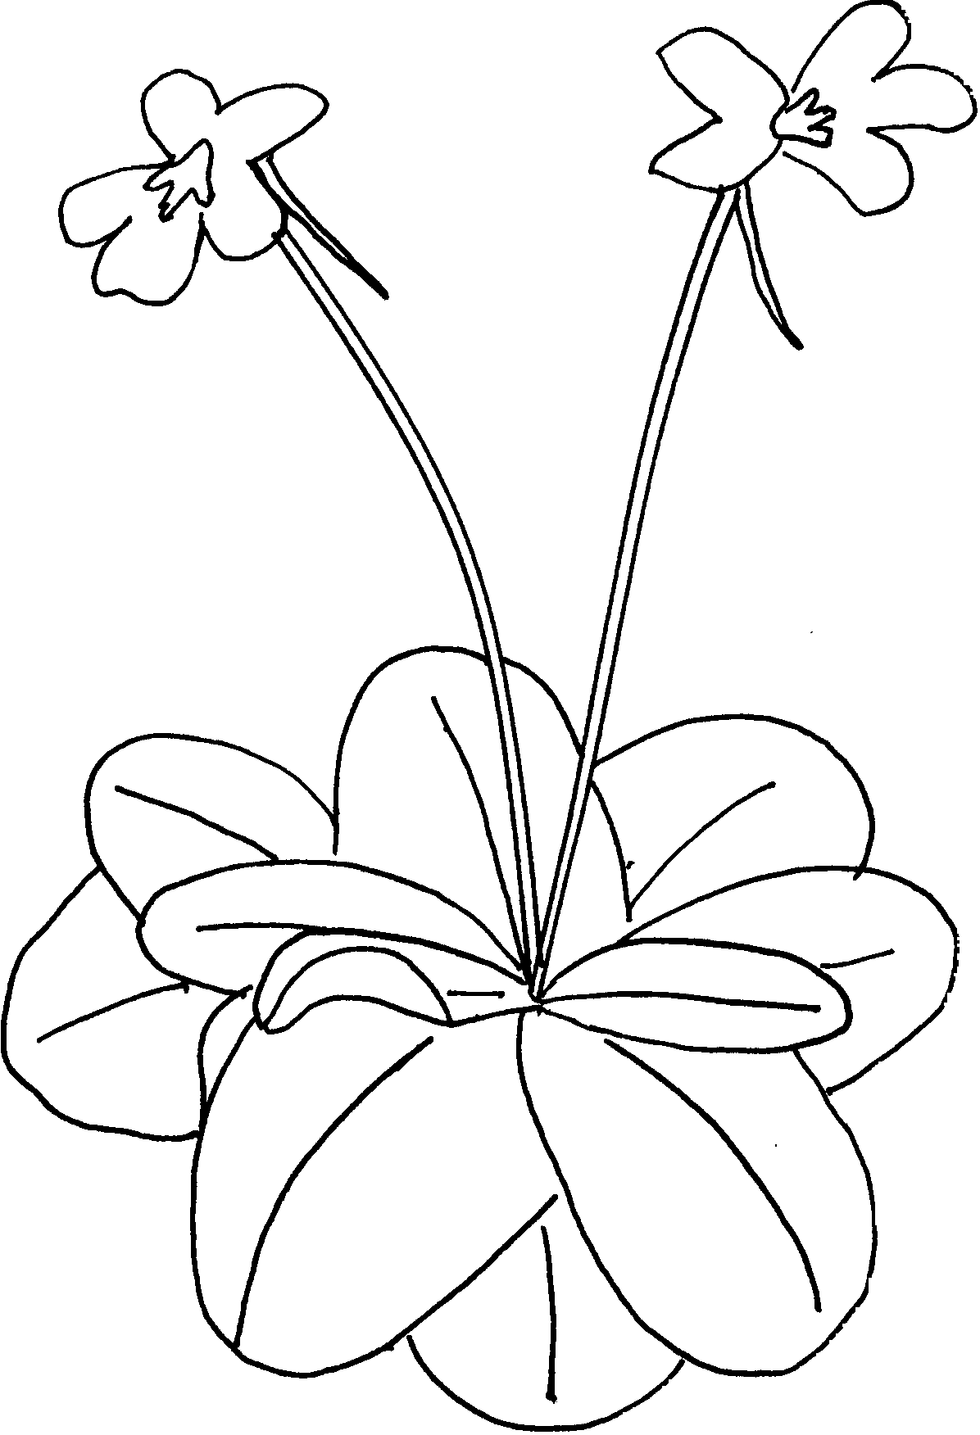
The tailed butterwort is one of the easy-to-grow Mexican species.

My story about butterworts

My drawing of butterworts

Venus flytrap facts

• How many kinds (species) of Venus flytrap are there?
• Are Venus flytraps found in our area?
• Where do Venus flytraps occur?

• How do Venus flytraps catch insects?

• What other carnivorous plants grow with Venus flytraps in the wild?

• To grow indoors, Venus flytraps need

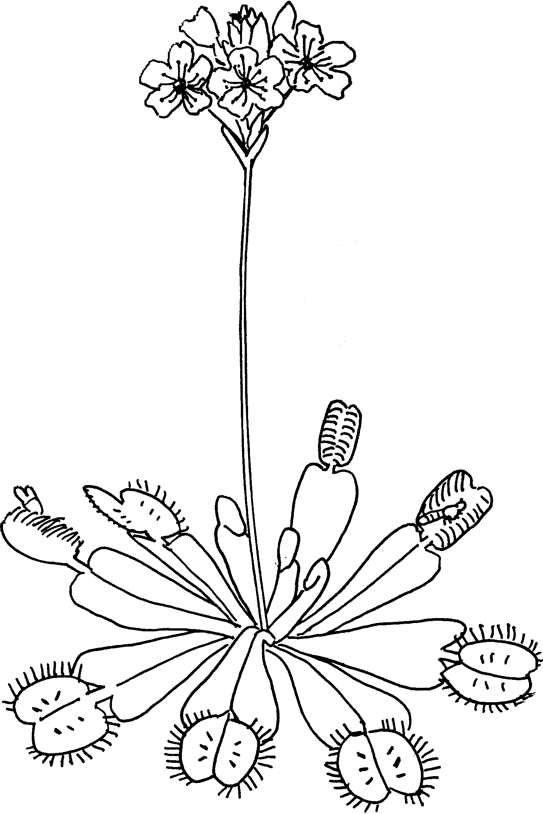
The native range of the Venus flytrap lies completely within 100 miles of Wilmington, North Carolina.

My story about Venus flytraps

My drawing of Venus flytraps

Pitcher Plant facts

• How many kinds (species) of Nepenthes tropical pitcher plants are there?
• Are Nepenthes tropical pitcher plants found in our area?
• How many kinds (species) of Sarracenia North American pitcher plants are there?
• Are Sarracenia North American pitcher plants found in our area?
• What other kinds of pitcher plants can you name?

• How do pitcher plants catch insects?

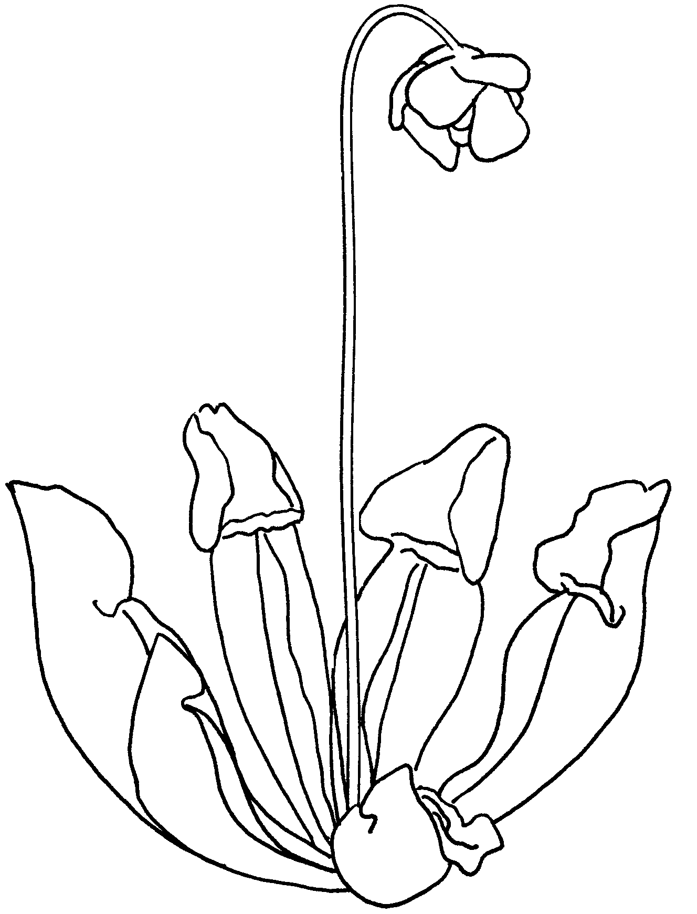

Sarracenia purpurea is found in bogs and fens across northern and eastern North America.

My story about pitcher plants

My drawing of pitcher plants

Baddererwort facts

• How many kinds (species) of bladderworts are there?
• Are butterworts found in our area?
• Where else are bladderworts found?

• How do bladderworts catch their prey?

• Butterworts catch insects in order to obtain essential they need.
• Special glands in the bladder traps release
to dissolve soft parts of the prey.
• Bladderworts that are epiphytes grow up in

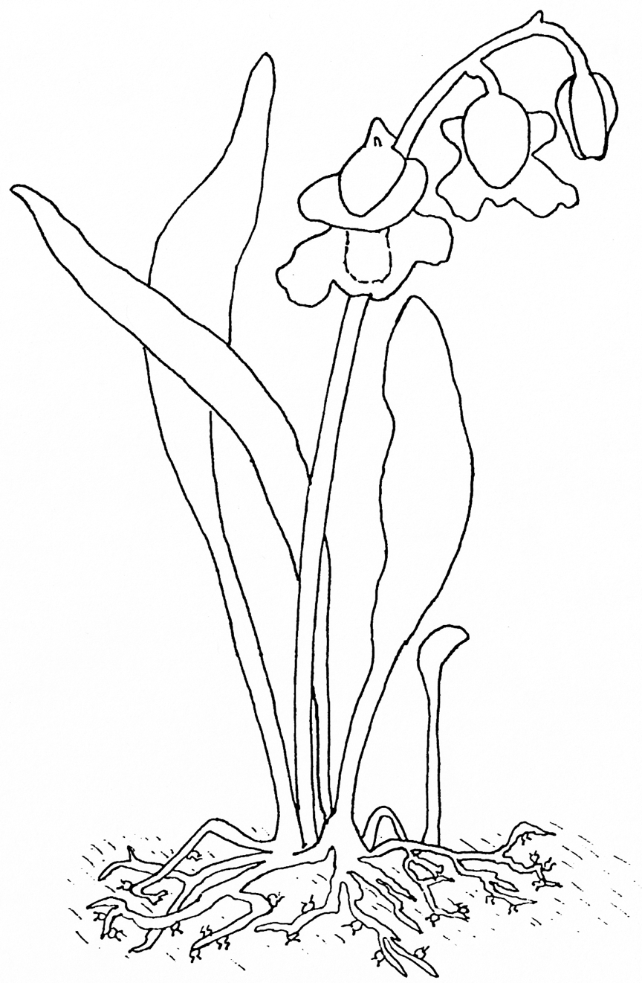
The alpine bladderwort is an epiphyte. It lives in the moss growing on branches of trees and captures small creatures in the moss.

My story about bladderworts

My drawing of bladderworts
- Read books on CPs and other exotic plants from your school or local library. Request additional books through interlibrary loan.

What can I do now with carnivorous plants (CP’s)?
- Look for CP videos at your local library or on the Internet. Watch for CP television specials.
- Learn more about CPs on the International Carnivorous Plant Society (ICPS) web site. http://www.carnivorousplants.org/
- Join the ICPS forum to ask questions and learn about CPs. http://icps.proboards105.com/
- Visit other CP web sites. There is a list of CP web sites on the ICPS web site under “Web Ring”.
- Grow your own CPs.
- Make a terrarium of nursery grown CP’s.
- Start CPs from seed.
- Visit botanical gardens that have CP exhibits.
- Visit a local bog. Take pictures only!
- Make a photo album of CP pictures.
- Collect CP pictures from nature magazines.
- Make a bog montage from collected pictures.
- Interview a naturalist about CP’s in your area.
- Help a conservation organization preserve CP habitat.
Modified from Activity Book for Carnivorous Plants, by Michael Szesze, 2003, htttp://www.carnivorousplantnursery.com
- Make an origami bug for your Venus flytrap puppet.
- Draw or paint pictures of your favorite CP’s.
- Paint a CP onto a smooth stone to make a knickknack. Paint several stones to make play bog. Paint bugs to eat as well as other bog plants.
- Paint your own CP T-shirt.
- Dress up as a CP for Halloween.
- Construct paper models of your favorite CP. Make a mobile out of them.
- Build a CP out of blocks, Lincoln logs or tiles.
- Make your own CP coloring book.
- Write a story about CP’s.
- Write a comic book about a funny CP happening.
- Make a word search puzzle using CP names and terms.
- Do a science fair project on CP’s.
- Do a class presentation on CP’s.
- Start up a CP club in your school. Do CP projects at school.
- Think up more fun things to do with CP’s.
The Weird, Wild, Wacky and Wonderful World of Carnivorous Plants Final Exam

Choose the one best answer.

1. Carnivorous plants capture, kill and digest
a. competing plants b. insects c. the seeds of other plants d. birds

2. Carnivorous plants tend to occur in habitats that are
a. dry b. lacking insects c. nutrient-poor d. dark, poorly-lit

3. About how many groups (genera) of carnivorous plants are there?
a. 2 b. 20 c. 200 d. 2000

4. About how many kinds (species) of carnivorous plants are there?
a. 5 b. 50 c. 500 d. 5000

5. The special glands on the leaves of carnivorous plants produce to break down their prey.
a. acids and enzymes b. baking soda and salt c. starch and fat d. vitamins and minerals

6. When growing carnivorous plants, it is best to water them with
a. distilled water b. soda water c. well water d. tap water

7. Which of the following is found nearby in the wild?
a. waterwheel plant b. tropical pitcher plant c. bladderwort d. California pitcher plant

8. In the wild, Venus flytraps are found in
a. Antarctica b. South America c. Europe d. North Carolina and South Carolina

9. Sundews catch their prey with
a. trigger-haired spring traps b. sweet, sticky tentacles c. slippery-walled pitchers d. high-speed vacuum traps

10. Butterworts received their name because of their
a. butter-like odor b. creamy yellow color c. greasy, buttery feeling leaves d. use in making butter

